|  |  |  |  |  |
| --- | --- | --- | --- | --- |
|  |  | | |  |
|  | | |
|  | | |
|  | | | |
|  | **Turkey R&D SADC - Hms Sandbox Project**  **Hms Sandbox Product Documentation** | | 附件1-16K |
|  | |
| **Issue** | **01** |
| **Date** | **2021-02-0**4 |
| HUAWEI TECHNOLOGIES CO., LTD. | |

|  |
| --- |
| **Copyright © Huawei Technologies Co., Ltd. 2020. All rights reserved.**  No part of this document may be reproduced or transmitted in any form or by any means without prior written consent of Huawei Technologies Co., Ltd.  **Trademarks and Permissions**  附件3-图 and other Huawei trademarks are trademarks of Huawei Technologies Co., Ltd.  All other trademarks and trade names mentioned in this document are the property of their respective holders.  **Notice**  The purchased products, services and features are stipulated by the contract made between Huawei and the customer. All or part of the products, services and features described in this document may not be within the purchase scope or the usage scope. Unless otherwise specified in the contract, all statements, information, and recommendations in this document are provided "AS IS" without warranties, guarantees or representations of any kind, either express or implied.  The information in this document is subject to change without notice. Every effort has been made in the preparation of this document to ensure accuracy of the contents, but all statements, information, and recommendations in this document do not constitute a warranty of any kind, express or implied. |

|  |  |
| --- | --- |
| Huawei Technologies Co., Ltd. | |
| Address: | Huawei Industrial Base  Bantian, Longgang  Shenzhen 518129  People's Republic of China |
| Website: | <http://www.huawei.com> |
| Email: | [support@huawei.com](mailto:support@huawei.com) |
|  | Document Information   |  |  |  |  | | --- | --- | --- | --- | | Prepared by | Cem Genar  c00568942 | Date | 2021-02-04 | | Reviewed by | Cagatay Kızıldag c00262224 | Date | 2021-02- | | Approved by |  | Date |  | |
|  |  |
|  | **Change History** |
|  | |  |  |  |  |  |  |  |  | | --- | --- | --- | --- | --- | --- | --- | --- | | Prepared by | Cem Genar  c00568942 | Remark | Initial Version | Version No | 1.0 | Date | 2020-02-04 | |
|  |  |

Contents

[Contents iii](#_Toc63409119)

[1 Introduction 1](#_Toc63409120)

[1.1 Overview 1](#_Toc63409121)

[1.2 Project Infrastructure 1](#_Toc63409122)

[1.3 Dynamic Modules 3](#_Toc63409123)

[2 User Interface 1](#_Toc63409124)

[2.1 General Layout 1](#_Toc63409125)

[2.1.1 App Usage 1](#_Toc63409126)

[2.1.2 HMS Core 5](#_Toc63409127)

[2.1.3 AGC (App Gallery Connect) 8](#_Toc63409128)

# Introduction

## Overview

HMS Sandbox is a complete interactive and reference set of HMS Core kits and services when developers and users seeks information about HMS Core.

This project has been developed as a mobile application with dynamic ability modules within the application which can be downloaded after the base application installed.

The purpose of the project is to help developers to find reference development examples, show the capabilities and abilities of HMS Core. To achieve this, kits are implemented in a simple and easy to understand way.

## What You Will Need

### Hardware Requirements

* One PC with Android Studio installed

### Required Knowledge

* Android development basics
* Java language

## Get the Sample Code

Clone the CodeHub repository from the command line:

$ git clone https://codehub-dg-g.huawei.com/hms---turkey-dtse-branch/team-c9/hms-sandbox.git

If Git is not available on the computer you are using then access to given URL through a WEB browser and download.

## Import the Code

From Android Studio, select the **hms-sandbox** directory (android_studio_folder.png) from the sample code download (**File > Open > …/hms-sandbox**).

## Project Infrastructure

HMS Sandbox project is built upon Android App Bundle technology and dynamic ability structure to minimize and optimize application data size and increase flexibility.

Each HMS Core module has its own manifest, gradle file and resource folders. Therefore users and developers only check for the desired kit implementation codes and resources. Because resources and classes are separate for each module, confusion is prevented by only reaching the codes of the desired module.

After installing HMS Sandbox application from App Gallery, it can be seen that Location Kit – Map Kit – Push Kit –Scan Kit and Site Kit modules are pre-installed.

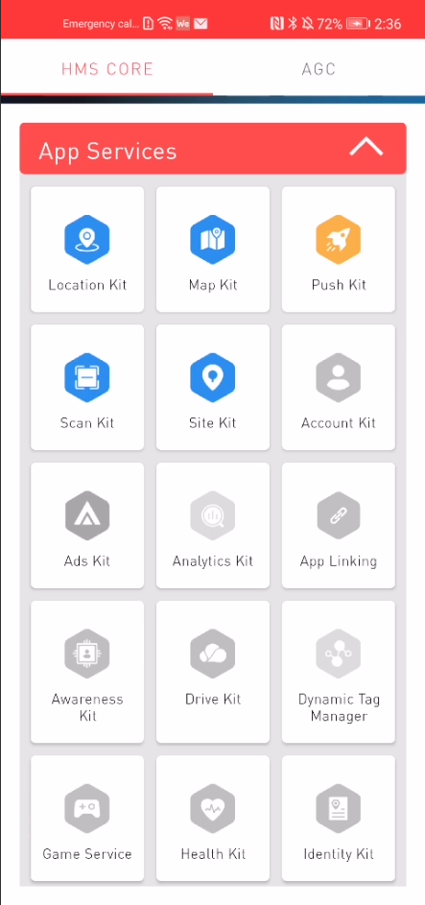

## Dynamic Modules

The application consists of 75 HMS Core modules in total, which are gathered in 2 general categories and 13 subcategories, listed below:

* HMS Core
  + App Services
  + Graphics
  + Media
  + AI
  + Smart Device
  + Security
  + System
* App Gallery Connect
  + Release
  + Build
  + Growing
  + Quality
  + Earn
  + Analytic

# User Interface

## General Layout

Tab layout is used to separate kits into 2 general categories which are HMS Core and AGC (App Galley Connect). Under these categories, sub categories are listed as shown above.

### App Usage

Installed and ready to use modules can be distinguishable easily. Installed features are appeared colored and ready to install modules are appeared with gray colored icons in categories.

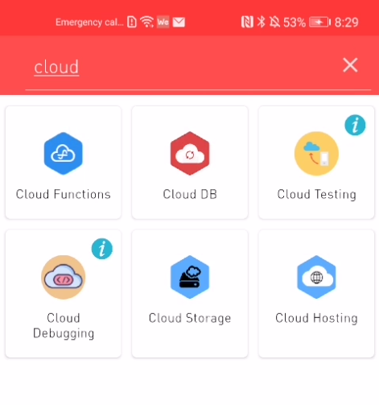

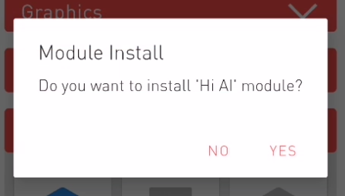Search functionality can be used to find desired modules because it could be difficult to find among 13 sub categories and 75 modules.

To install a dynamic module, desired module icon is clicked and a dialog box is appeared. After clicking ‘YES’, selected module will be downloaded. After a successful download and install, the module will be ready.

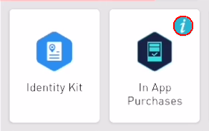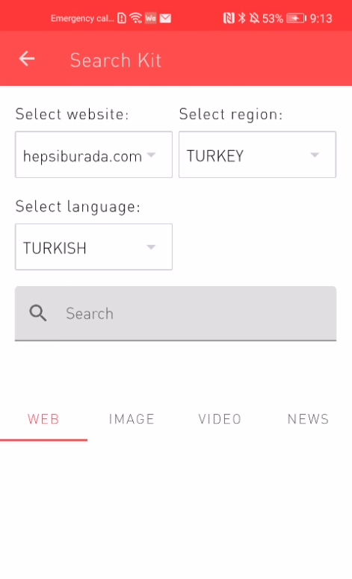

There are 2 types of dynamic modules. Interactive modules which developers can explore kit functionalities and capabilities, Change variables and see output results of the functions.

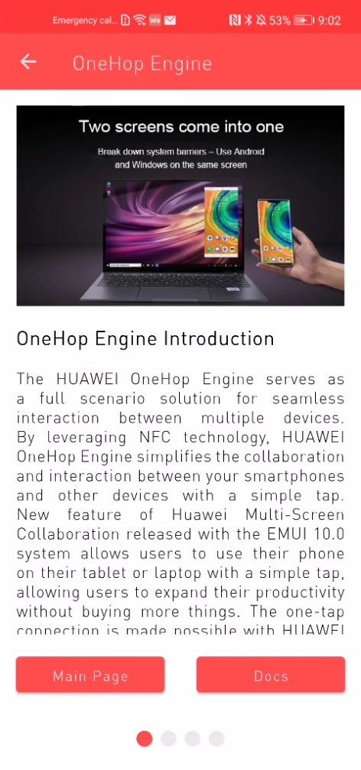

The other one is reference modules, which are marked with a blue information icon on the right upper corner, which explain the kit or service functions, give clear examples and refer to related documentation website.

### HMS Core

HMS Core offers a rich array of open device and cloud capabilities, which facilitate efficient development, fast growth, and flexible monetization. This enables global developers to pursue groundbreaking innovation, deliver next-level user experiences, and make premium content and services broadly accessible.

This category is consist of 7 sub categories and 45 modules which are listed below.

* + App Services
  + Account Kit
  + Ads Kit
  + Analytics Kit
  + App Linking
  + Awareness Kit
  + Driver Kit
  + Dynamic Tag Manager
  + Game Service
  + Health Kit
  + Identity Kit
  + In App Purchases
  + Location Kit
  + Map Kit
  + Push Kit
  + Quick App
  + Scan Kit
  + Search Kit
  + Site Kit
  + Wallet Kit
  + Graphics
  + Accelerate Kit
  + AR Engine
  + Computer Graphics Kit
  + Scene Kit
  + Media
  + Audio Engine
  + Audio Kit
  + Image Kit
  + Panorama Kit
  + Video Kit
  + WisePlay DRM
  + AI
  + Hi AI
  + HiAI Foundation
  + ML Kit
  + Smart Device
  + CaaS Engine
  + Cast Engine
  + Device Virtualization Engine
  + OneHop Engine
  + Share Engine
  + Wear Engine
  + Security
  + Data Security Engine
  + Fido Kit
  + Local Authentication Engine
  + Safety Detect
  + System
  + hQUIC Kit
  + Nearby Service
  + Wireless Kit

### AGC (App Gallery Connect)

App Gallery Connect is a one-stop open platform covering the entire app lifecycle: innovation, development, distribution, operation, and analysis. It helps to build and run apps faster and better, while growing the experience and revenue.

This category is consist of 6 sub categories and 30 modules which are listed below.

* Release
  + App Bundle
  + App Release
  + App Signin
  + Early Access
  + Phased Release
  + Preorders
* Build
  + Auth Service
  + Cloud DB
  + Cloud Functions
  + Cloud Hosting
  + Cloud Storage
  + Connect API
  + Dynamic Ability
* Growing
  + A/B Test
  + App Linking
  + App Messaging
  + Comments
  + Gift Management
  + Product Management
  + Remote Configuration
* Quality
  + App Performance Management (APM)
  + Cloud Debugging
  + Cloud Testing
  + Crash Service
  + Integration Check
  + Open Testing
* Earn
  + App Gallery Kit
  + Paid Apps
* Analytics
  + Distribution Analysis
  + Operation Analysis